Waves
You should have a main page title Waves on Weebly.

Use the following link to find information: (There are 4 lessons on this page)
http://www.physicsclassroom.com/class/waves

I have narrowed down to what you need to know for each lesson and should be on your Weebly page.
Lesson 1
- What is a wave?
A disturbance in energy that goes through a medium and travels to a different location.
- What are the different categories of waves? Give examples of each type. (pg 497 in the book is helpful for this)
-Transverse Waves – Light Waves
-Longitudinal Waves – Sound Waves
-Surface Waves – Ocean Surface Waves (put a bottle in the ocean, and the bottle floats in about one spot because it’s travelling in a circle)

-Electromagnetic Waves – Light Waves
-Mechanical Waves – Sound Waves

Lesson 2
- Define wavelength of a wave and then get a picture from the web of what a wavelength is.
Wavelength is the distance from either crest to the same point on the next crest or trough to the same point on the next trough on a wave.
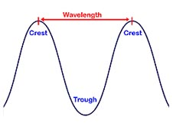
- Define frequency of a wave
The frequency of a wave is how often the particles of the medium vibrate when a wave is passing through it.

Use this simulation to answer the next question: http://www.physicsclassroom.com/Physics-Interactives/Waves-and-Sound/Simple-Wave-Simulator/Simple-Wave-Simulator-Interactive
- What is the relationship between wavelength and frequency? Screencapture the interactive to show the relationship between wavelength and frequency.
Wavelength and frequency have an inverse relationship. When the frequency is low, the wavelength is high. When the frequency is high, the wavelength is low. Look below:
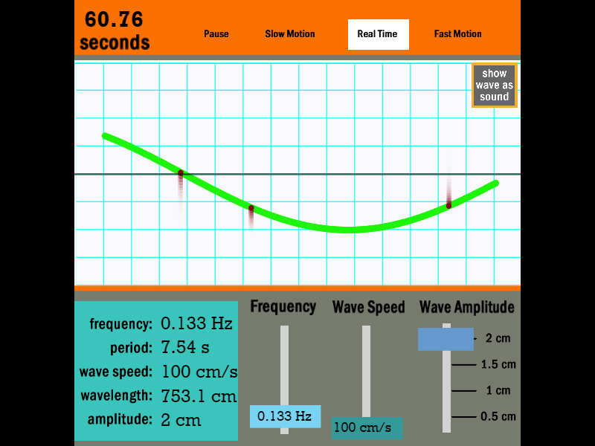0.133 Hz frequency, 753.1 cm wavelength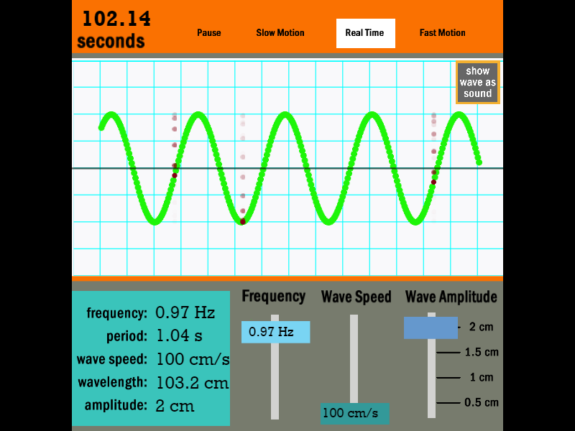0.97 Hz frequency, 103.2 cm wavelength
Lesson 3
- What are constructive and destructive waves? ** For this question, instead of using the website, use page 498 in the book.
Constructive interference (constructive waves) is when the crests of two waves or the troughs of two waves overlap, causing them to become one wave with a higher amplitude. Destructive interference (destructive waves) is when the crest of one wave overlaps with the trough of another, causing them to become one wave with a lower amplitude.

- What is Doppler Effect? Provide a real life example.
The Doppler Effect is a perceived change in frequency of a wave when either the producer or the receiver is in motion. An example would be if an ambulance with its sirens on driving past you. When it moves right by you, the siren sounds very high-pitched. When it moves farther away, the sound sounds very low-pitched until you eventually cannot hear it anymore.

Lesson 4 - You do not need any information

Electromagnetic waves

